Dr. Hanumanthaiah.K.S. (MBBS, MS, DNB, FIAGES, FRCS) 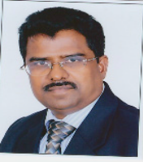
Contact: +91 9731209246 (M) E-mail: namria73@gmail.com

PROFESSIONAL VALUE OFFERED
- A Diligent & Dedicated Professor of General Surgery for over 25 years with Post-graduation in General Surgery from Bangalore Medical College and as consultant surgeon in Malaysia at Tertiary Care Hospital for more than 5 years and attached to Unimas Medical College, Kuching, Malaysia.
- Perform all major and minor surgical procedures with special interest in all G I T surgery, experienced in diagnostic and therapeutic procedures of upper and lower Endoscopies.
- Trained in laparoscopic surgery from Indian institute of Laparoscopic surgery. V.G. Hospital Coimbatore and awarded FIAGES –fellowship Indian Association of Gastrointestinal Endo-surgeons.
- Teaching theory as well as surgical techniques to undergraduates and postgraduate students. Guide as well as Postgraduate examiner to the postgraduate students. Teacher for diagnostic and therapeutic Upper and lower GI scopies to the junior faculty in the department.
- Life Member of Association of Surgeons of India, Indian Association of Gastrointestinal Endo-Surgeons, Indian Hernia Society, Indian Medical Association and Association of Surgeons of India, Bangalore Chapter.
- Impressive track record in guiding and teaching advanced surgical procedures including laparoscopic procedures while adhering to strict guidelines and processes; driven by a passion for achieving high quality at work.
- Possess strong administrative, man management skills, mentoring & relationship management skills while maintaining high standards of personal performance and professionalism.
- Currently performing 30 -35 advanced LAPAROSCOPIC surgeries per month including advanced surgeries for the past 8 years.
PROFESSIONAL & ACADEMIC CREDENTIALS
FRCS Fellowship Royal College of Surgeons (Glasgow) 2016
- FIAGES Fellowship Indian Association of Gastrointestinal Endo Surgeons 2012
- DNB Diplomate in National Board, New Delhi 1993
- MS – Gen. Surgery Bangalore Medical College, Bangalore University 1991
- MBBS Bangalore Medical College, Bangalore University 1987
CAREER PROGRESSION
RajaRajeswari Medical College, Bangalore Professor 01st Jan 2013 till date
RajaRajeswari Medical College, Bangalore Associate Professor 01st Apr 2011 – 31st Dec 2011
A.C.S. Medical College, Chennai Associate Professor 01st Jan 2009 – 31st Mar 2011
A.C.S. Medical College, Chennai Assistant Professor 21st Nov 2008 – 31st Dec 2008
Unimas Medical College, Kuching, Malaysia Faculty/Consultant Surgeon 1997 - 2008
Siddhartha Medical College, Tumkur Lecturer Oct 1991 – Sep 1996
TEACHING EXPERIENCE
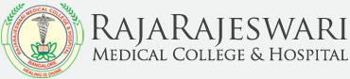 RAJARAJESWARI MEDICAL COLLEGE, Bangalore 01st Apr 2011 till date
Professor 01st Jan 2013 till date
Associate Professor 01st Apr 2011 – 31st Dec 2011
- Professor of General surgery and running out - patient care, preoperative care, performing operation and postoperative care with utmost care up to the patient satisfaction.
 A.C.S. MEDICAL COLLEGE, Chennai 21st Nov 2008 – 31st Mar 2011
Associate Professor 01st Jan 2009 – 31st Mar 2011
Assistant Professor 21st Nov 2008 – 31st Dec 2008
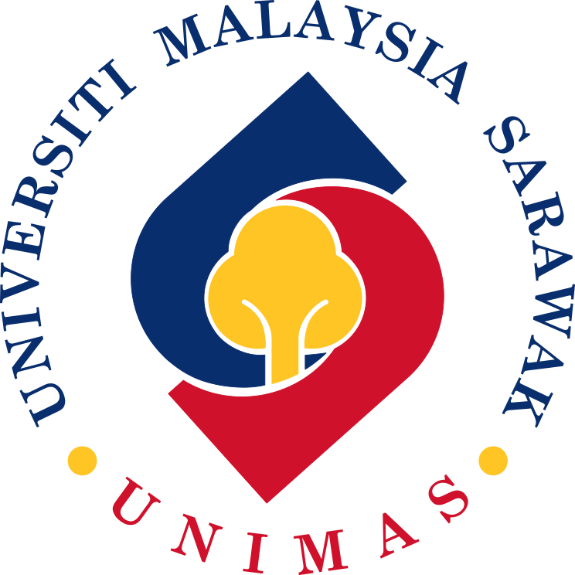 UNIMAS MEDICAL COLLEGE, KUCHING, MALAYSIA 1997 -2008
Faculty/Consultant Surgeon
- A consultant surgeon at a Tertiary Care Hospital and attached to Unimas Medical College, Kuching, Malaysia.

 SIDDHARTHA MEDICAL COLLEGE, TUMKUR Oct 1991 – Sep 1996
Lecturer
SURGICAL COMPETENCIES
- Gastric Resection/Colonic Resection/Whipples Surgery/ Distal Pancreatectomy/Abdomino-Perenial /Diaphramatic/Resection/Hernia Repair/Transhital/Esophecgectomy/Thyroidectomy/Fundoplication
- Expertise In Basic And Advanced Laparoscopic Surgeries
STRENGTHS AND SKILLS
- Experience in teaching under graduates and post graduates in surgical skills as well as train them in accordance with the most recent updates.
- Performing all major and minor surgeries including several complicated cases, can also treat all surgical cases with good postoperative care and better prognosis.
- Performing all basic and advanced laparoscopic surgeries and can impart training to the junior faculties.
- Performing diagnostic as well as therapeutic Upper and Lower GI scopies and can provide hands on training to junior faculty and postgraduates.
- Experience in conducting Seminars/Conferences.

SPECIAL TRAINING
- Laparoscopic training from Indian institute of laparoscopic surgery, V.G. Hospital Coimbatore.
- Research fellow in dept of Liver and Transplantation surgery, Chang Gung Transplantation Institute, Chang Gung University Medical School, Taiwan. Underwent training in Hepatico Biliary Surgery from Taiwan.
PUBLICATIONS
- Retained Rectal Foreign body and its Management Protocol, Volume 7, Issue 2. JULY 2014. PAGES 51-55 - People’s Journal of Scientific Research july 2014 Vol.7,issue 2
- Chemical sphincterotomy versus surgical sphincterotomy (Lateral internal sphincterotomy) for chronic fissure-in-Ano – Outcome - Volume 3/Issue 22/June 2, 2014. Sl.No.43. PAGES 6243-6251. Journal of Evolution of Medical and Dental Sciences
- Giant Vesical Calculus – Case report – Journal of evolutation of Medical and Dental sciences – Vol 3/Issue22/June2.2014.
- Fetus in Fetu: Case report and review of literature. Journal of international medical sciences academy. January – March 2014/Vol.27/No.1.
- Patent Urachus in a Neonate presenting with severe umbilical Bleeding: case report - Volume 27/ Issue -1. Jan-March 2014. Pages 27. Journal of International Medical Sciences Academy
- Extrahepatic biliary ductal variations and its clinical significance. J. Evolution Med. Dent. Sci. 2016;5(30):00-00, DOI: 10.14260/jemds/2016/1.
RESEARCH UNDERGOING
- HEALICOLL – An alternative for flap in bare bones and tendons for wound cover.
MEMBERSHIPS & POSITIONS OF IMPORTANCE
- Life member of Association of Surgeons of India.
- Life member of Indian Association of Gastrointestinal Endo-Surgeons.
- Life member of Indian Hernia Society.
- Life member of Indian Medical Association.
- Life of member and past secretary of Association of Surgeons of India, Bangalore Chapter.
PERSONAL INFORMATION
Address: 294, 10th Main, NGEF Layout, Nrupathunganagar, Nagarabhavi, Bangalore–560072 Karnataka
Date of Birth: 03rd May, 1963
Marital Status: Married
Nationality: Indian
E-Mail: namria73@gmail.com

